# TEST & INSTRUCTION

*Note: (1) In this section, we aim to present you several serials of scenarios for all roles* *in the web by attempting to cover all cases may happened in real life to let you get a better understanding after reading document in RULE, FUNCTIONALITY & FEATURE IMPLEMENTATION section. However, if missing cases found, you can try yourself freely by playing with the web or* ***refer back to RULE, FUNCTIONALITY & FEATURE IMPLEMENTATION section*** *for detail explanation after going through* *this TEST & INSTRUCTION section, because you will be asked to initialize some data here to test the web.*

*(2) If you have already generated some data in the web, you can resume the web back to ‘to be test’ status by executing given MYSQL script called ‘dataInitialization.sql’ in test folder.* **Please use MySQL database ‘zy21586’ of username ‘zy21586’ with password ‘Daniel=1997=’**

**Initialized data**

1. Mask

The mask unit price will be initialized for the sale department.

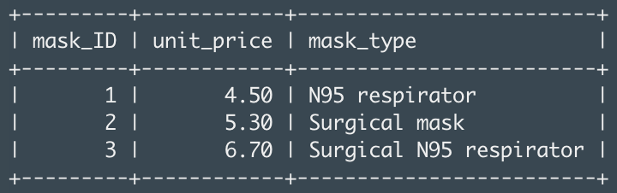

1. Customer

There will be 1 customer account initialized for each country, you will be instructed to use this account to test the web.

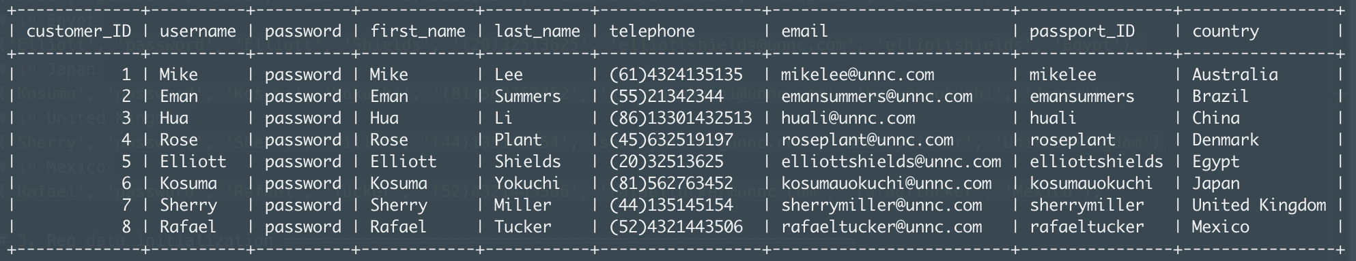

1. Sale Rep

There will be 2 sale reps account initialized for each country with active working status and 1000 quota quantity, you will be instructed to use this account to test the web.

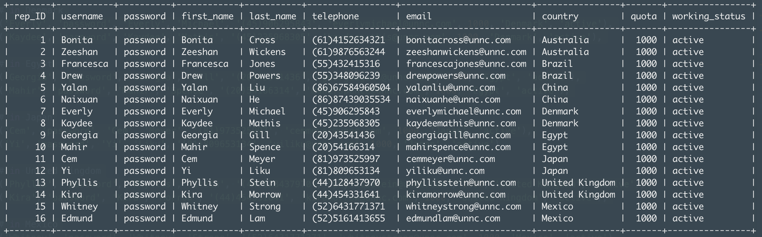

**Access web page**

For your convenience, we have added links into the index page to let you choose between 2 web entries easily: (1) for user (customer and sale rep); (2) for manager. (As mentioned in USER & INTERFACE section, two different entries should be separated for different roles)

Please access web by this link:

**<http://cslinux.nottingham.edu.cn/~zy21586/>**

And then choose the role you will test by clicking two buttons below:

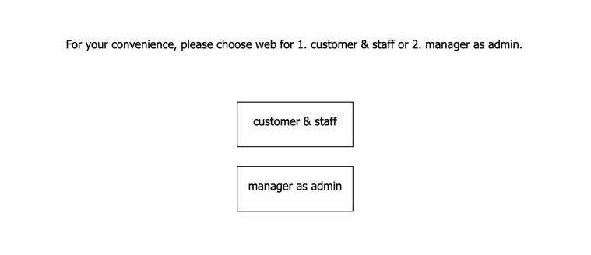

**Scenario 1**

In this scenario, we intend to provide you a basic instruction of basic operations can be done by customers, reps and manager for letting you acquainted with this system. Later on, some comprehensive scenarios will allow you to get better understanding of the whole system.

In this scenario, please kindly follow the flow chart given below by expected sequence: **1. First act as a customer 2. Then act as a sale rep 3. At last act as a manager,** which will show you how the system works and how the data will be updated through the system.

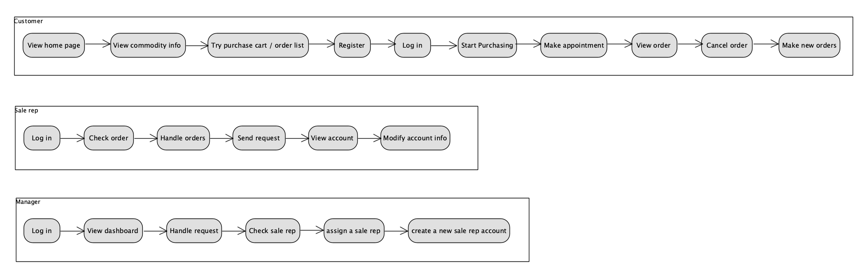

Customer

1. View home page

Firstly, you will act as a new customer of this sale system, please access the web for users by clicking customer & staff button as mentioned in access web page section.



Then, to act like a new customer, you must want to view the home page without logging in by clicking home page button at left-top corner.



1. View commodity info:

Then you will be directed into home page, now you can check commodity info by hover items in sub-navigation bar.



Hover

You will notice that (1) there is a welcome message inform you to log in; (2) There is a log in button at the right-top corner in the navigation bar. But you don’t want to log in right now.

1. Try purchase cart / order list

Now, you can try to click orders button in the navigation bar or purchase cart button at the right-bottom corner.



You will notice that after clicking the orders button or pay button in purchase cart section, you will be alerted to log in and redirect to log in section. Now it is time for you to register!

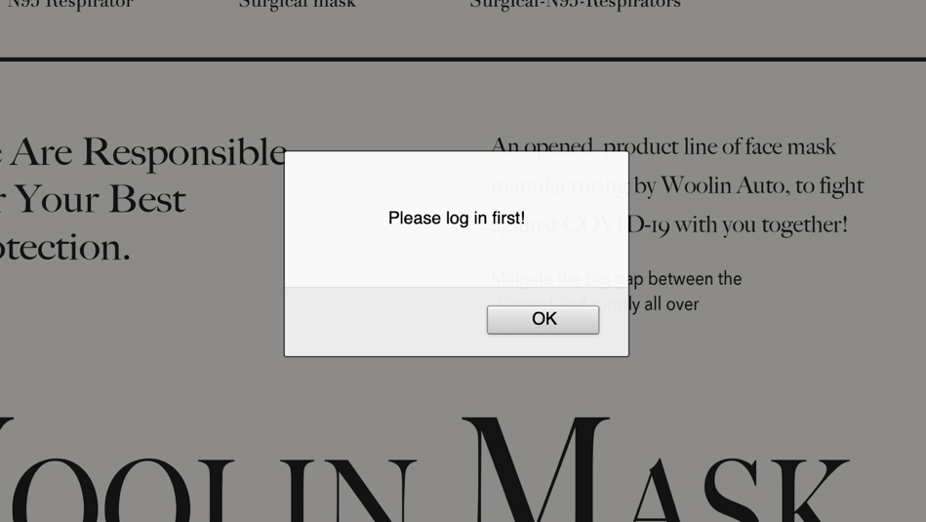

1. Register

Assuming that you **haven’t** had any account yet, try click register button to switch to register yourself with given data (**the further instruction will base on given data below**). Before entering correct information given, try input some **strange value** and see what will happen (prompt messages will pop out and you will be refused to register).

|  |  |  |  |  |  |  |  |  |
| --- | --- | --- | --- | --- | --- | --- | --- | --- |
| Username | Password | First name | Last name | Country code | Tel number | email | Passport ID | Country |
| Daniel | Password | Daniel | YANG | 86 | 15901184506 | [Danielyang@unnc.com](mailto:Danielyang@unnc.com) | danielyang | China |

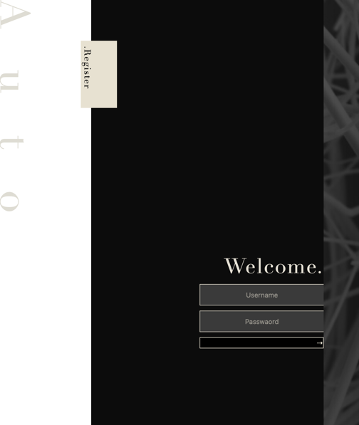 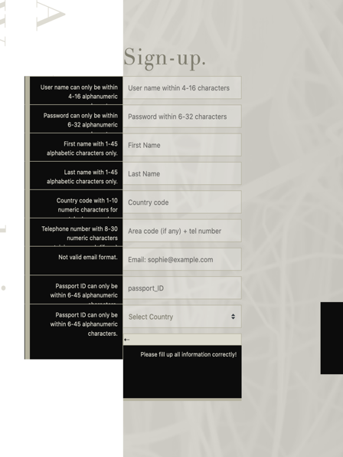 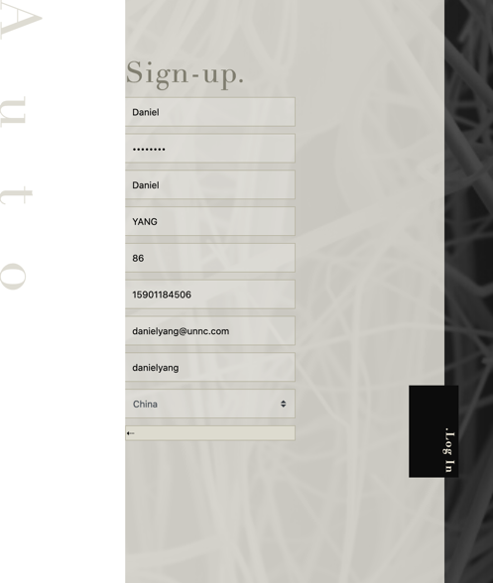

Once you register success, you will be directed to log in section automatically.

1. Login

After logging in, you will be directed to home page now. You will notice that (1) the welcome message now contains your username and (2) the login button has swtiched to logout.



1. Start purchasing

Now you can start purchasing in purchase cart section.

1. Try to **click - / + buttons** to adjust the quantities of each type of commodity.
2. Try to enter value directly to change quantity.
3. Try to enter some **invalid** value and see what will happen.
4. Finally, adjust your order quantities same as **given below** for further testing:

|  |  |  |
| --- | --- | --- |
| N95 Respirator | Surgical Mask | Surgical N95 Respirator |
| 200 | 200 | 200 |

1. The total amount will be **$ 3300.00,** now click pay button



1. Make appointment

Now an appointment section will slide from right hand side for you to choose a sale rep currently serving in your country.

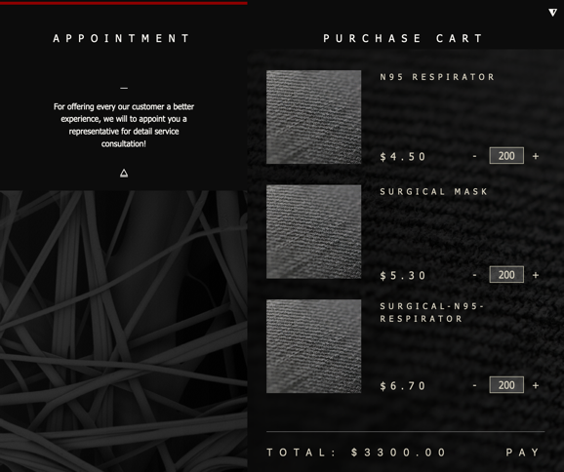 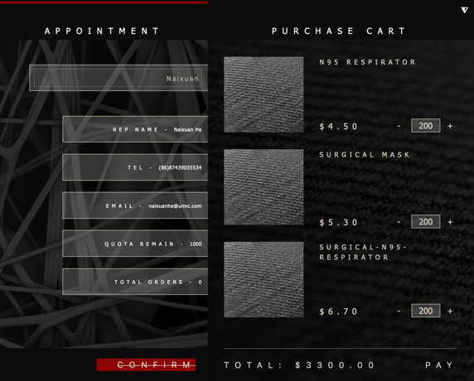

Please choose ‘**Naixuan’** as your sale rep, because we will act as him in later instruction. (If your current selection bar doesn’t contain any rep’s name, clicking confirm button will be alerted.)

After **pressing confirm button** successfully, your order will be created formally, a confirmation message with detail order information will slide in!

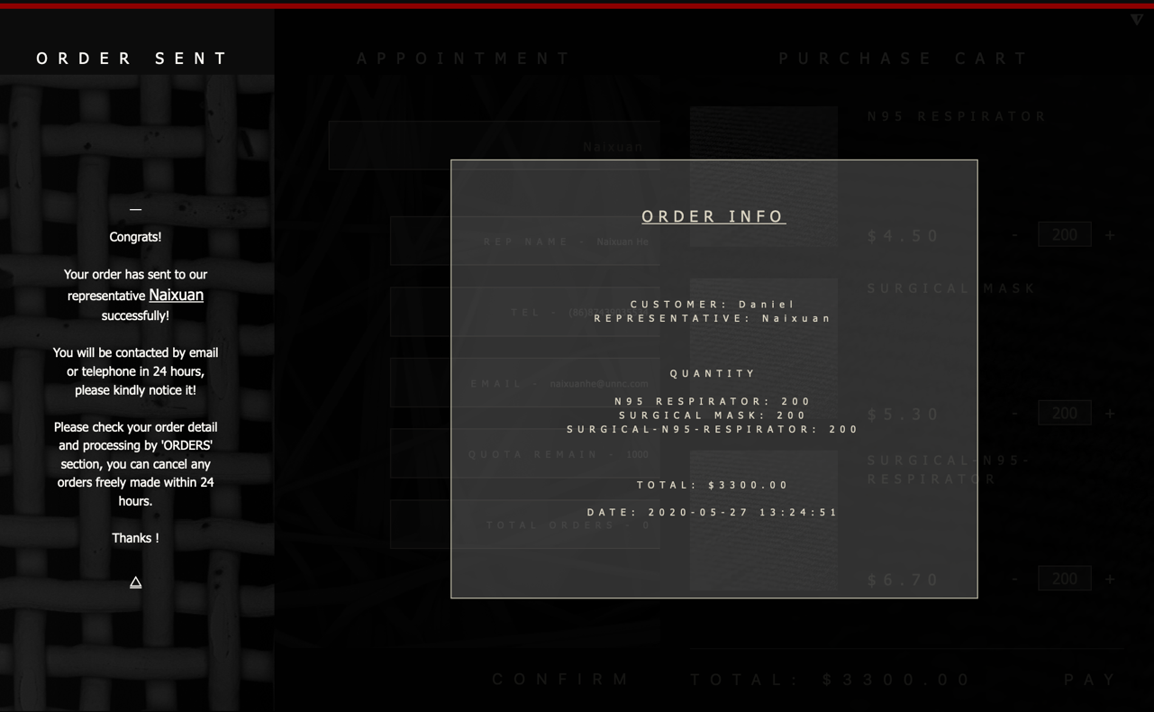

Notice that the confirmation message will contain your sale rep’s username and the date time is uniformly GMT(Greenwich mean time). After check your order info, click **small triangle button to exit.**

1. View order

Now you can click **orders** button in right-top corner of navigation bar to view all your orders (currently you should only have one order shown). 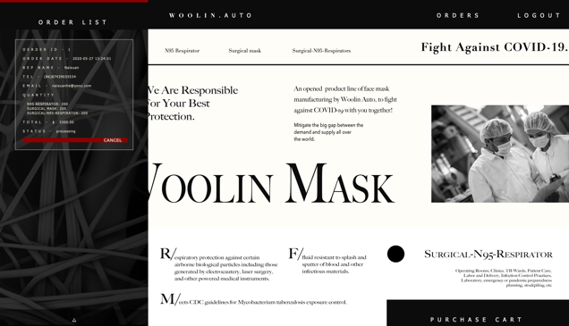

The order list will slide from left hand side and please notice your order is now in **processing status.**

1. Cancel order

Now assume that you want to cancel your order because some mistakes, try to click **cancel button** and see what will happen. (Because your current order **is within 24h**, you will be secondly asked to confirm cancelling the order, and then cancel it successfully.)

Once your cancel is done, the order list will **refresh** automatically and you will notice the specific order status will be **cancelled by user**, now try to cancel it again see what will happen!

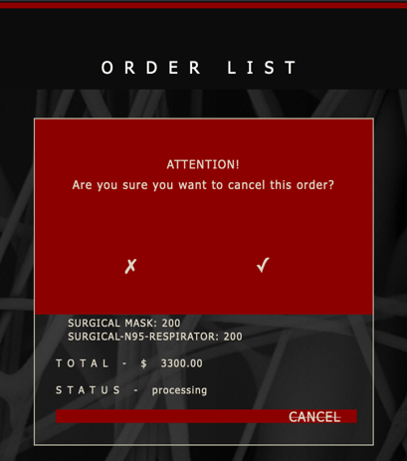 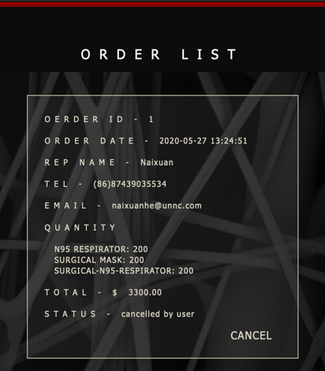 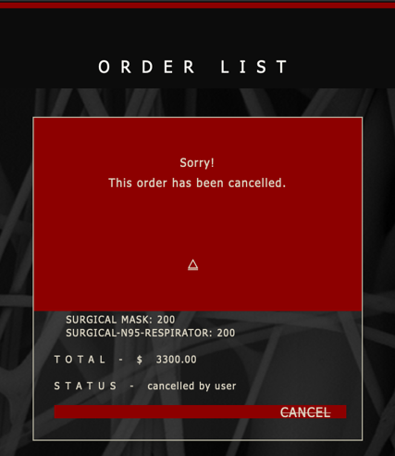

Finally, click the **small triangle button** to fold the order list section, and move on.

1. Make new orders

As you have already been familiar with the ordering process, now let’s make two more order as given data below (**these orders will be tested in later instruction** when acting as sale rep and manager, **please kindly follow the instruction** ☺)

Make **two more orders** with the same quantities exactly as that of the first order, (namely, choose sale rep as **Naixuan** and quantities are **200, 200, 200**). You will have 3 orders presented in **scrollable** order list section.

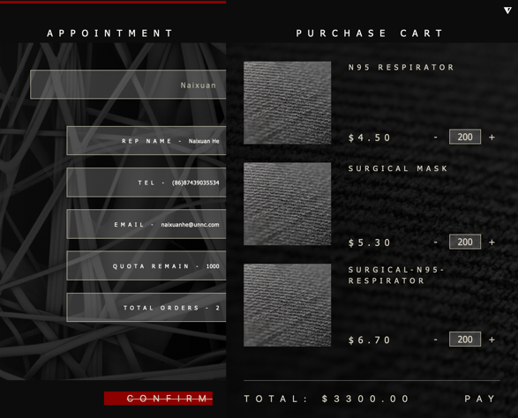 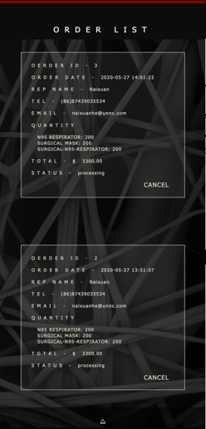

(one cancelled by user and two in processing)

You will notice that every time you make a new order, the total orders of sale rep Naixuan will be enhanced by 1, **even that order has been cancelled**. (This is happening only in customers’ page to present a **maximized performance of sale reps to customers**, later in sale reps’ and manager’s page, the order statistics will separate orders in **different status** (cross reference to RULE, FUNCTIONALITY & FEATURE IMPLEMENTATION section for more detail)).

Congrats, you have done acting as customer in scenario 1, now move on to check sale rep’s view!

Sale Rep

1. Log in

Now please **logout** from the customer Daniel’s account and go back to log in section. Find and click the staff entry in the left-bottom corner, you will be redirect to the log in section of staff page.

 

(There will be no more register section as it is the manager’s task to create sale reps accounts)

Please log in with initialized sale rep account **Naixuan** by given data below as we have appointed 3 orders to him.

|  |  |
| --- | --- |
| Username | Password |
| Naixuan | password |

1. Check order

After logging in, a navigation bar will fade in. Let’s now click **orders button** to check the all orders appointed to you.



You will see exactly 3 orders ordered by descending order ID in the **scrollable** list sliding from left hand side (two in processing status and one cancelled by user. All of them are under **not sold** post status).

You can check for detail information of each order by **clicking detail button.**

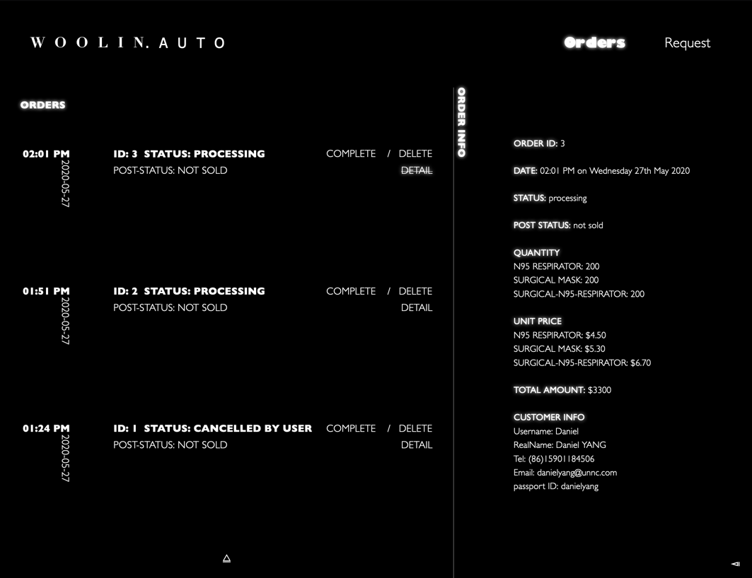

1. Handle orders

Now let’s try to handle some orders by following instruction.

1. Try to **cancelled the order with ID 1** **with delete button** and see what will happen.
2. Try to **complete the order with ID 1 with complete button** and see what will happen.

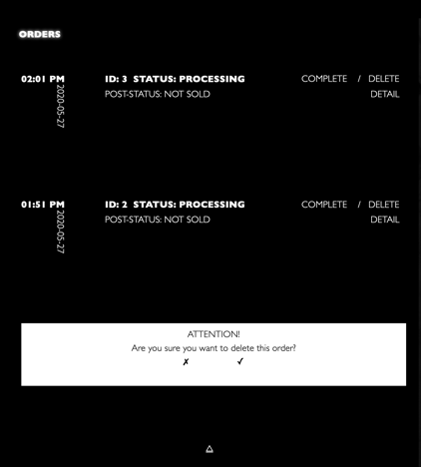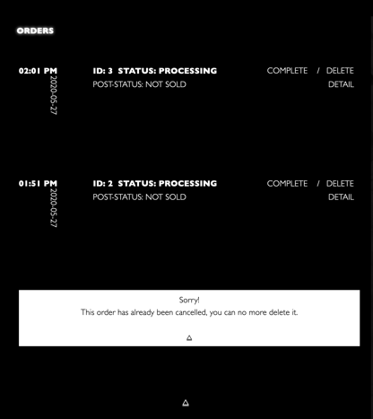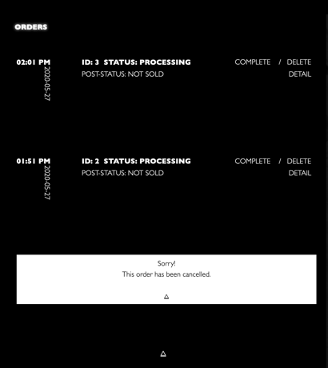

(When cancelling, you will be asked for second thought; If the order has already been cancelled or completed, you will be alert accordingly to the mistake you made)

1. Try to **cancelled the order with ID 2 with delete button** and see what will happen. (This will alert you because your current quota is enough to complete the specific order)
2. Therefore, this time when trying to **complete the order with ID 2 with complete button** you will finally success. The status of that order will update automatically and synchronize to database. (status: completed, post status: normal)

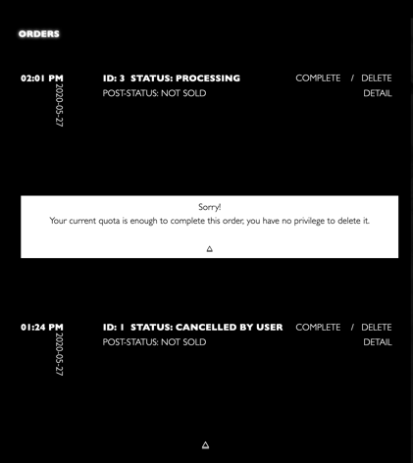 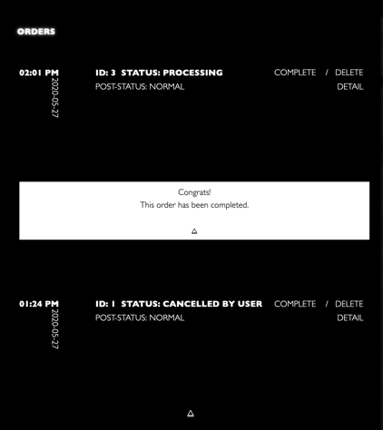 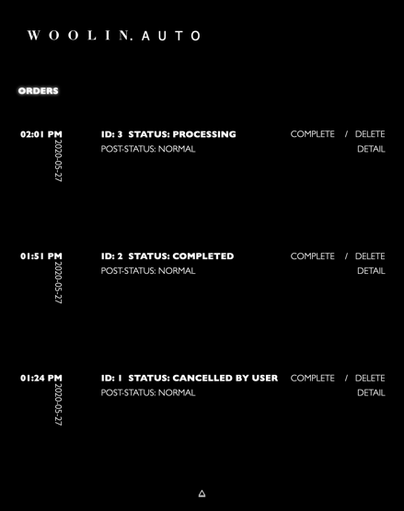

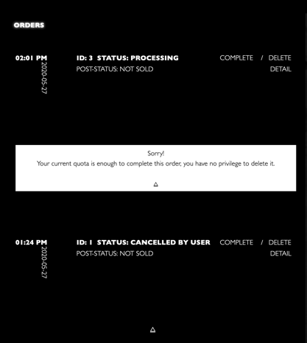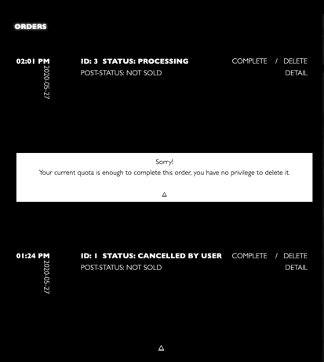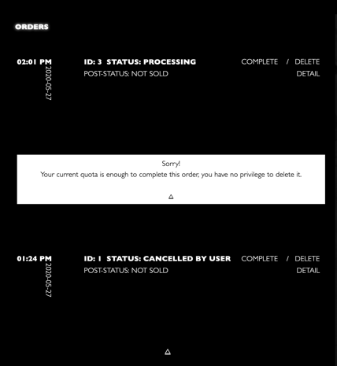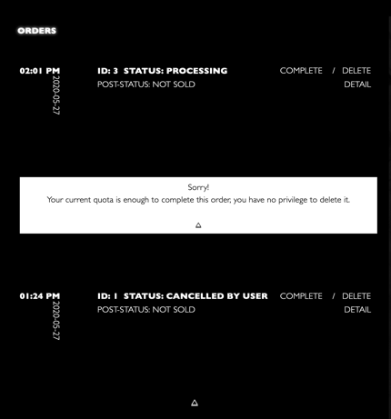

1. Now let’s **complete** the last order: **order ID: 3**.

Oops, you will be refused because your current quota is insufficient after finishing the second order with quantity 600 (recall that your initial quota is 1000, meaning **that only 400 is now left**, you will be instructed to ask for more quota later, don’t panic!)

1. This time let’s just **delete** the order assuming you have contacted the customer by their telephone or email. You will success by confirmation message and the status of that order will update automatically and synchronize to database. (status: cancelled by rep, post-status: not sold)

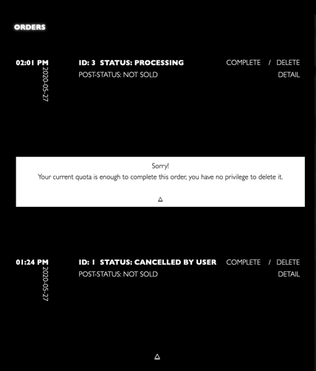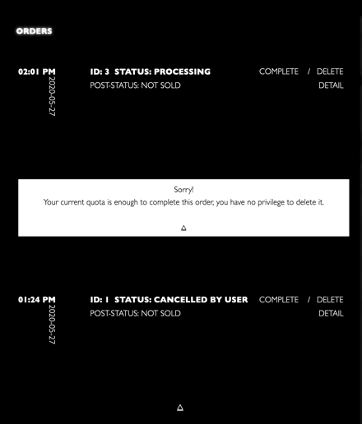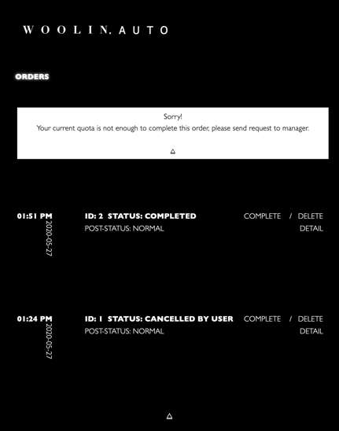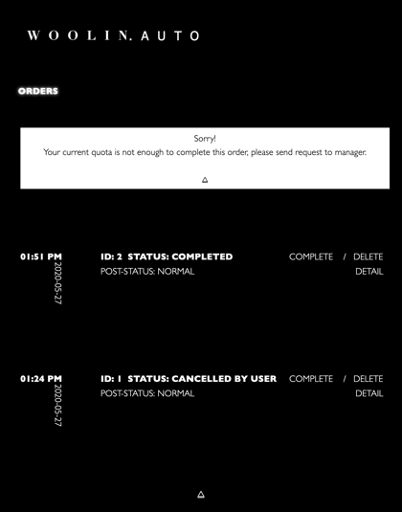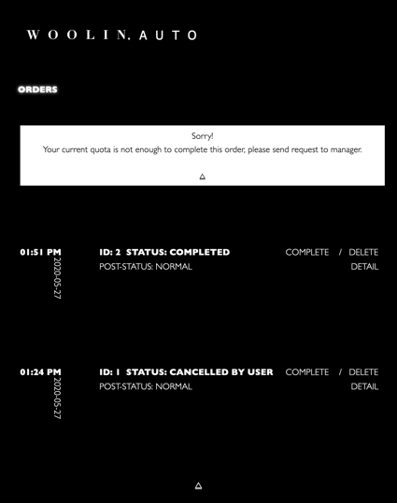 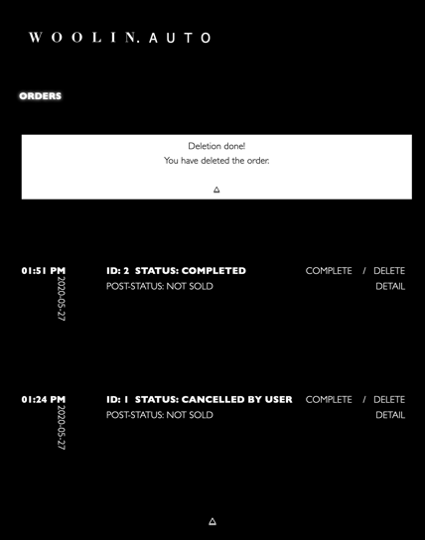 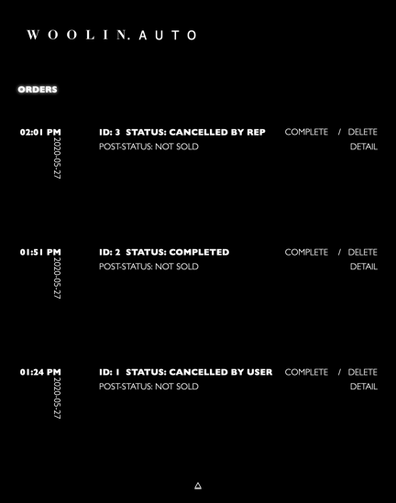

1. Send request

Having knowledge that your quota is currently not enough, you can now move to request section to send request by **clicking request button** in navigation bar.

You will be noticed with your current **quota remaining is 400, and you can ask for UPDATE** (if <=, the message will be ‘quota exceeding’ and ‘regrant’). The **default quota** request quantity is 1000, you can change as you wish (try to input some invalid value will be alerted).

Now let’s send the request by clicking send request button and you will be prompted with confirmation. Then **try second round** to send another request, you will be refused because you have already had a request **with ‘no response’ status to be handled by manager** (see RULE, FUNCTIONALITY & FEATURE IMPLEMENTATION section for detail explanation) (we will handle the request later when acting as manager).

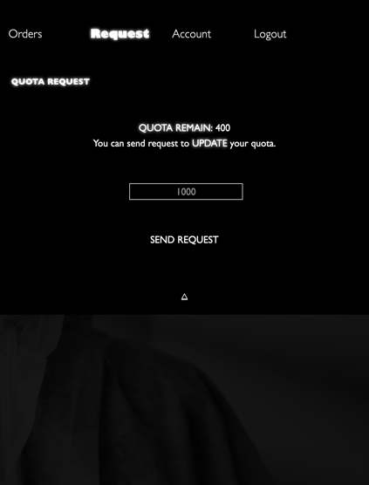 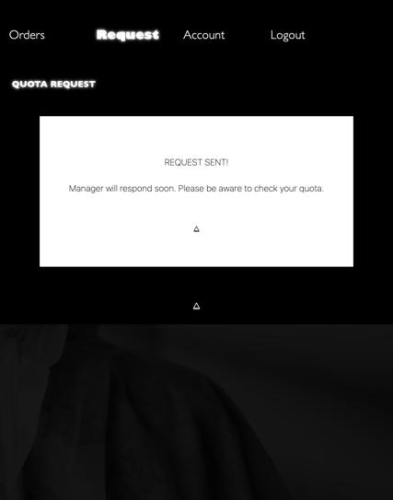 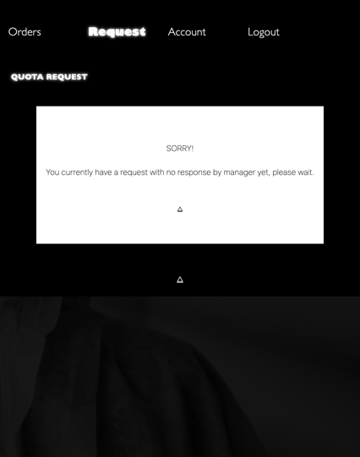

1. View account & modification

After sending request, you can check your account information by clicking **account button** in navigation bar.

This section will contain 3 parts:

(1) The basic information of sale rep’s account.

(2) The graphical statistical data of sale rep’s performance.

(3) The account modification section.

We only provide sale reps 3 kinds of information changeable (password, telephone number and email address) after creation by manager (**see RULE, FUNCTIONALITY & FEATURE IMPLEMENTATION section for detail explanation**).

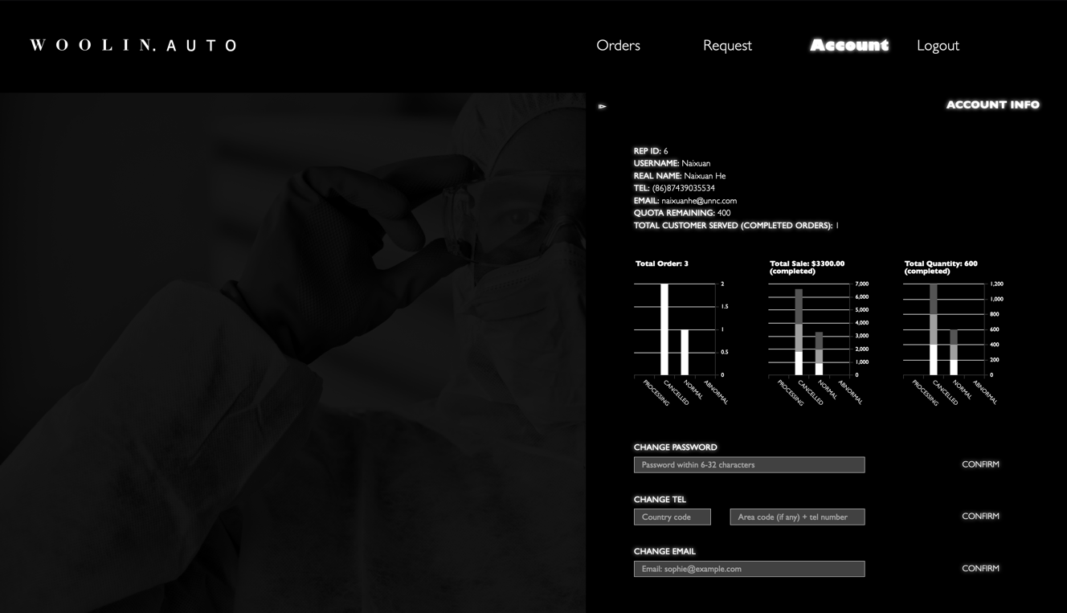

You can try to modify some information as you wish, and the data will be changed in this section and synchronized to database once **you click confirm button.** And the validation mechanism is similar as that in register section (**see RULE, FUNCTIONALITY & FEATURE IMPLEMENTATION section for detail explanation**).

Congrats, you have done acting as sale rep in scenario 1, now move on to check manager’s view!

Manager

1. Log in

As mentioned in **RULE, FUNCTIONALITY & FEATURE IMPLEMENTATION section,** the username of manager is ‘manager’ and password is ‘password’ which are embedded in source code. Please go back to link: <http://cslinux.nottingham.edu.cn/~zy21586/> and click **manager as admin** entry to log in.

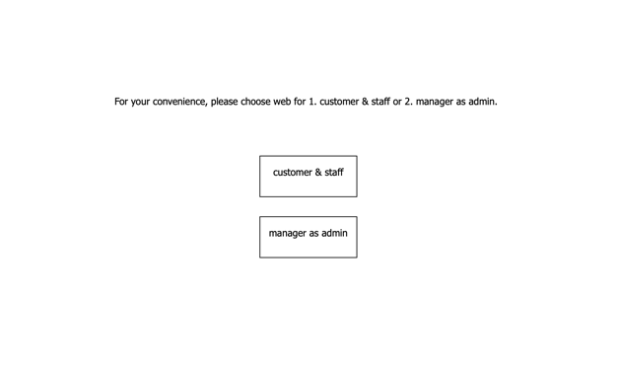 

1. View dashboard

After logging in, what presented to you is a dashboard section with various panels

(Please **see RULE, FUNCTIONALITY & FEATURE IMPLEMENTATION section for detail explanation of functionality of each panel**). Now try to play with it by following instruction: 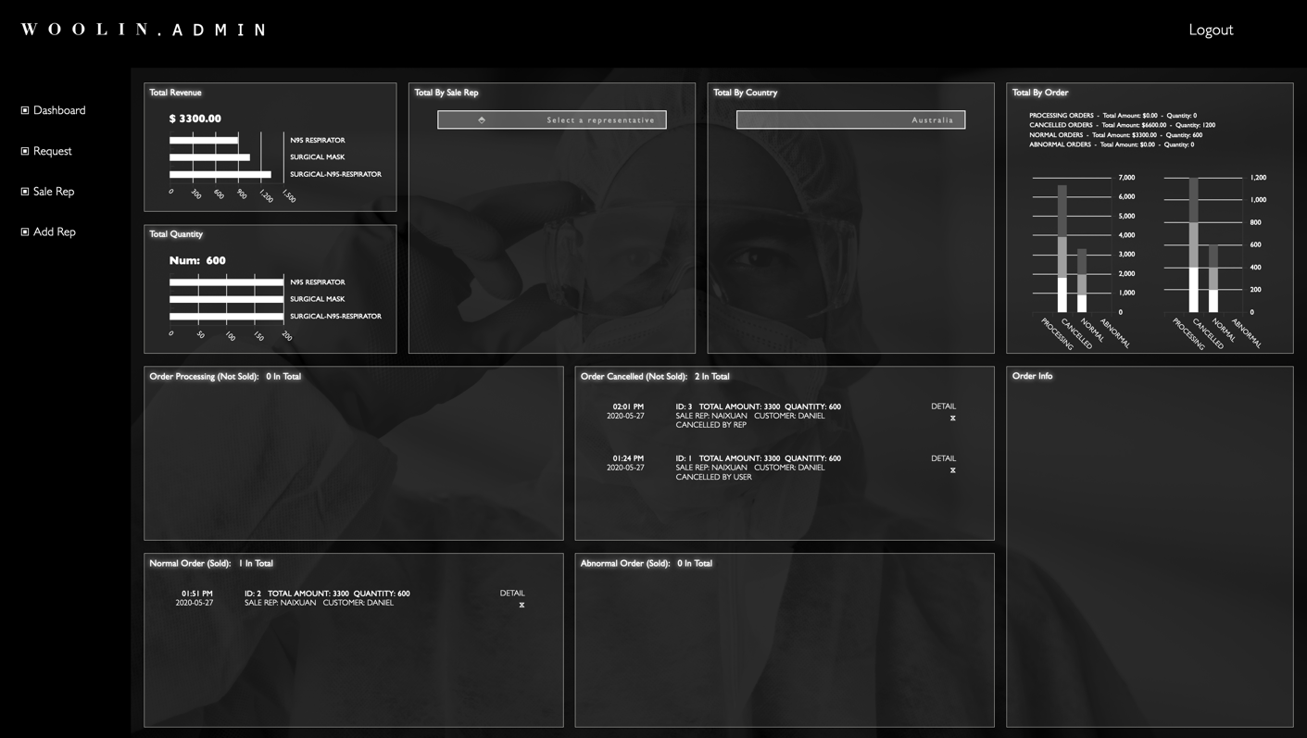

1. Total Revenue:

Recall that, so far, we have made 3 orders with only 1 order (ID: 2) completed. The total revenue will describe total amount of completed orders (both normal orders and abnormal orders) (see DATABASE DETAIL section to check order status and post status). Therefore, the total revenue is exactly the total amount in order ID 2. You can **hover above the graph** to check detail info.

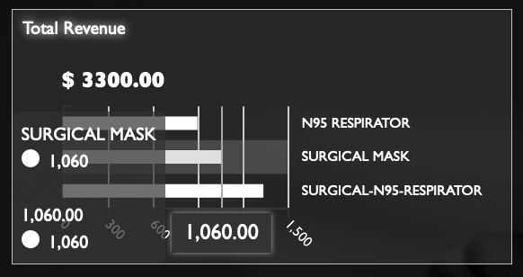 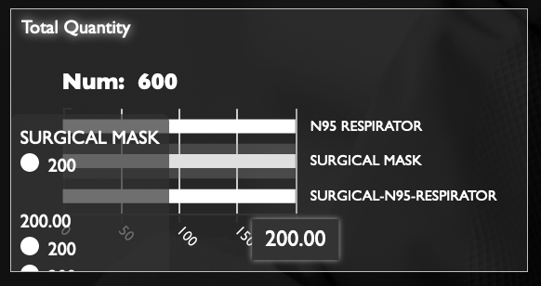

1. Total Quantity:

Similar as total revenue, the total quantity panel now containing the data exactly same in order ID 2, namely, 600 masks.

1. Total By Sale Rep:

In this panel, you can check total statistics for specific rep, all reps except **Naixuan** will contain nothing because they don’t have any orders yet.

Let’s select **Naixuan** now.

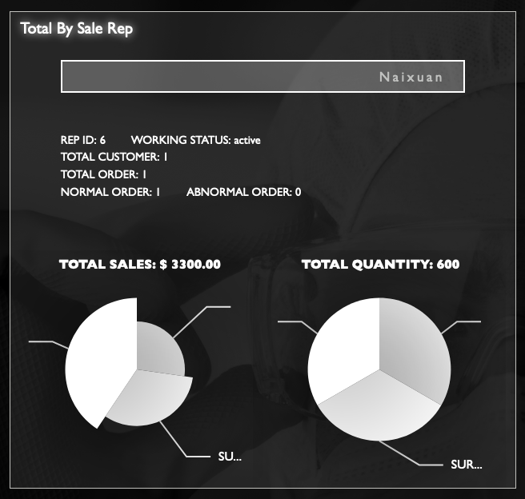

You will notice, as mentioned in sale rep’s instruction, the total order here only contain completed orders, **excluding orders in processing and cancelled.** Therefore, 1 normal order.

1. Total By Country:

This panel is similar as panel above, with an additional rep number of current active and left reps in that country. Let’s **select China**, in which our testing customer and rep are.

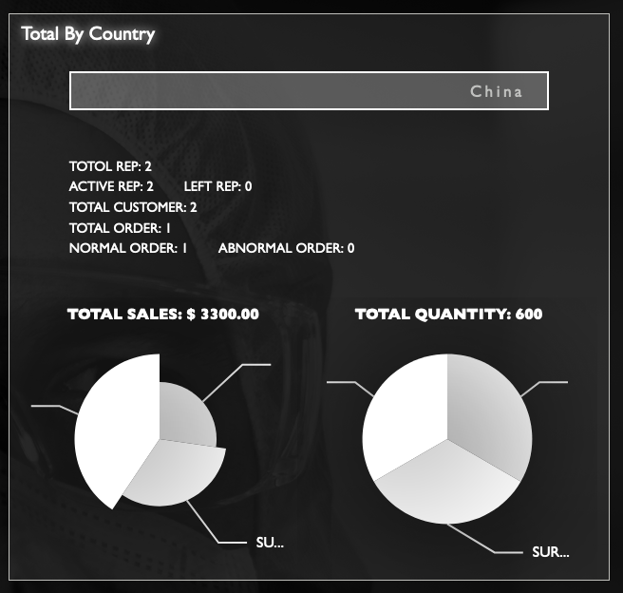

1. Total By Order:

This panel counts data separated by 4 kinds of status of orders (processing, cancelled, normal and abnormal, **where processing and cancelled are not sold orders, normal and abnormal are order sold**)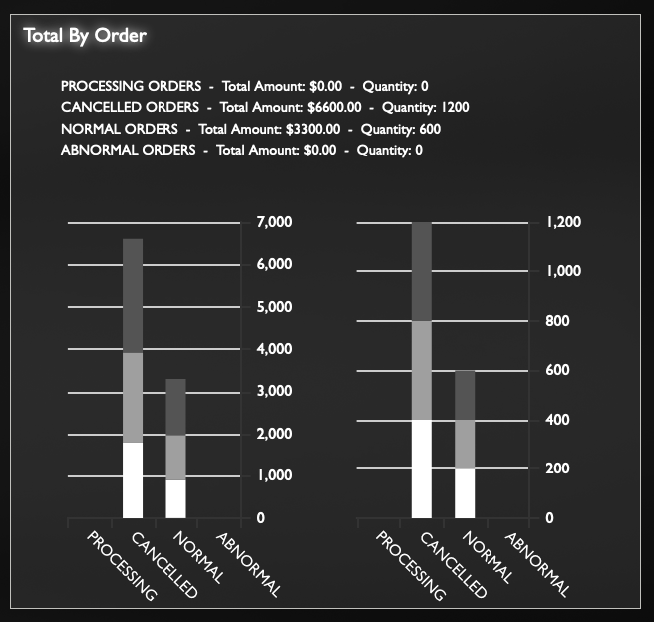

1. Order lists:

These **scrollable** panels containing all orders in total separated by four status mentioned above. You can check detail information by **clicking detail button.**

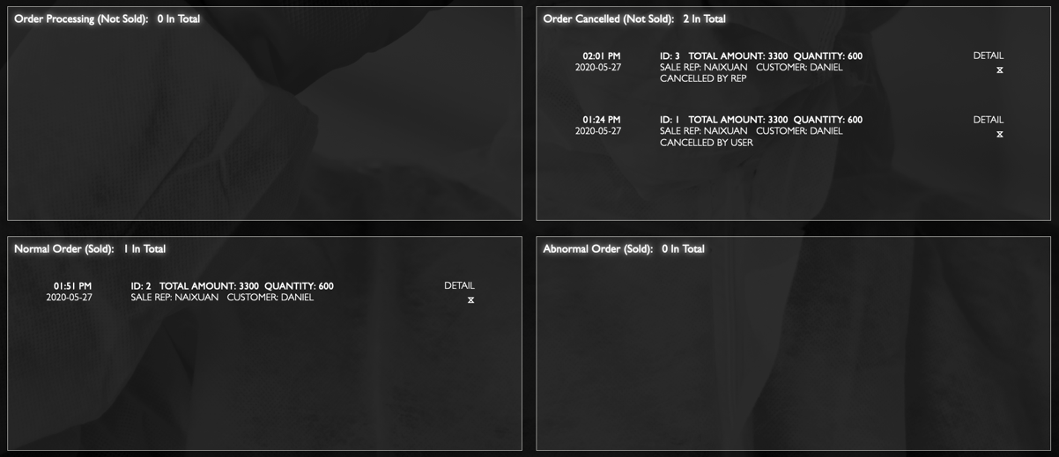

1. Order Info

Let’s click order ID 3, all information of that order will fade in in the **order info** panel. This panel will additionally describe the detail information and performance of specific customer, but manager cannot view customers’ info directly by searching their name for privacy issue (see **RULE, FUNCTIONALITY & FEATURE IMPLEMENTATION section for detail explanation**).

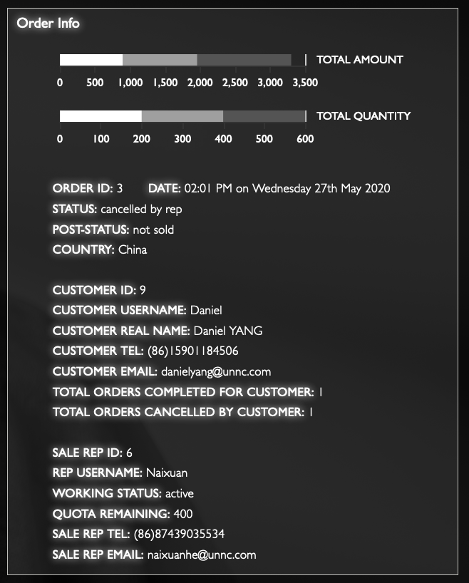

1. Handle request

After checking dashboard, now let’s move on to handle requests asked by sale reps for quota. Recall that we currently have sent **only one request by Naixuan.**

Therefore, by clicking **request button** in left hand side navigation bar you will see that request with ‘’no response’ status in red line in scrollable request list.

Now let’s try to handle this request by following instruction:

1. As you can see the quota remaining for Naixuan is 400 which is positive now, your available options will be **update and refuse,** (if the quota remaining is <= 0, the options will switch **to regrant and refuse (see DATABASE DETAIL for status of request)** automatically, which will be experienced in second scenario)
2. Now let’s click refuse button to refuse the request for now. You will be prompt accordingly and the information in request list will be updated automatically and synchronized to database.

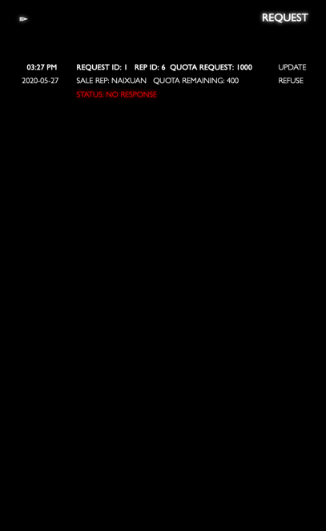 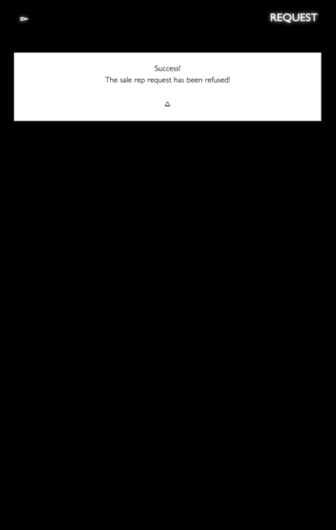 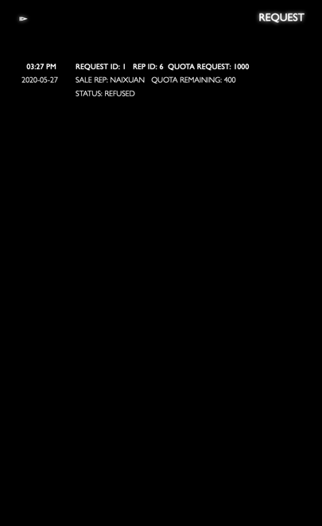

1. Check Sale Rep & Assign a rep

Now click **Sale Rep button** in left navigation bar to check Naixuan’s detail information.

This section will contain 4 parts similar as what in sale rep’s account section:

1. Basic information of specific sale rep.
2. Statistics data describing performance of sale **rep similar with the Total By Rep panel.**
3. Region assigning section for (1) assign a sale rep without current region to a selected region; (2) reassign a sale rep to another region.
4. Working status change: You can change sale reps working status as ‘active’ or ‘left’ (see DATABASE DETAIL section for further explanation) for statistics issue, we don’t delete rep info even one has left for good.

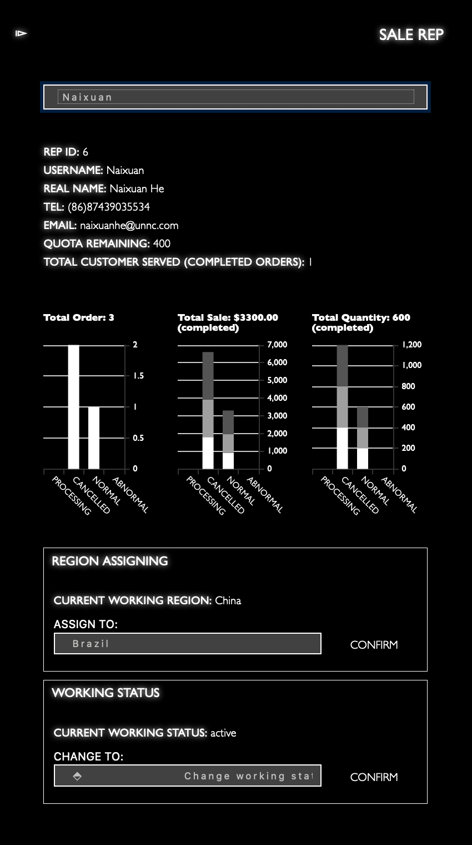

1. Create a new sale rep

Now let’s add a new member by clicking Add rep button in left navigation bar with given information below!

|  |  |  |  |  |  |  |  |  |
| --- | --- | --- | --- | --- | --- | --- | --- | --- |
| Username | Password | First name | Last name | Country code | Telephone | Email | Quota | Country |
| Cindy | password | Cindy | Li | 44 | 13212352304 | cindyli@unnc.com | 1000 | United Kingdom |

After creating successfully, you can go back in sale rep section to view her information now!

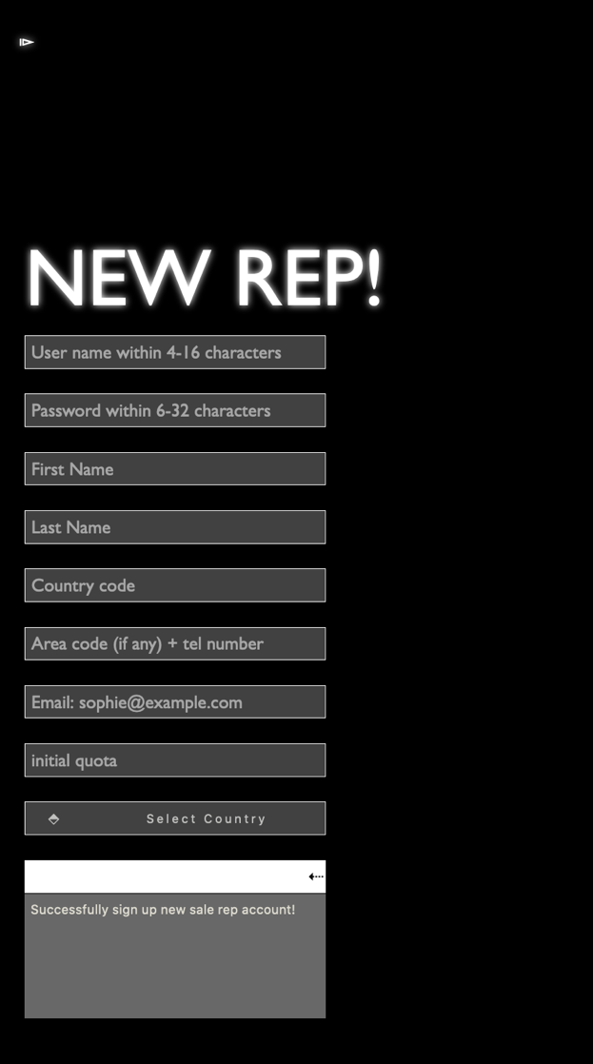 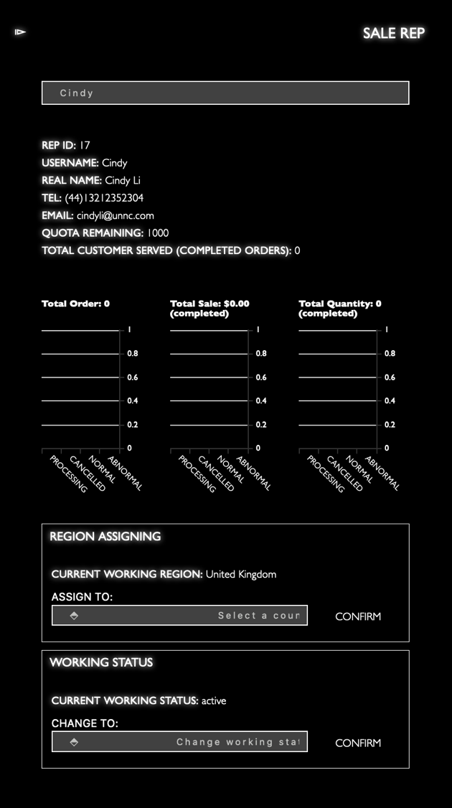

Congrats! You have walked through whole scenario1 now. You can now go through scenario 2 for getting more comprehensive understanding of the system, appreciate!

**SCENARIO 2**

In this scenario, we will provide more cases interacting with **time** element, a list of orders will be initialized for you by executing sql script in file ‘**dataScenario2.sq**l’of test folder.

*Note: This script will delete all information you have created in scenario 1 but keep all data initialized intact.*

As you will see, there are 3 orders initialized by script whose time has been exceeding 24h for enough long time. Now let’s see how customers, sale reps and manager will play with these.



Please also follow the flow chart’s sequence by 1. Act as customer, 2. Act as sale rep, 3. Act as manager in this scenario.

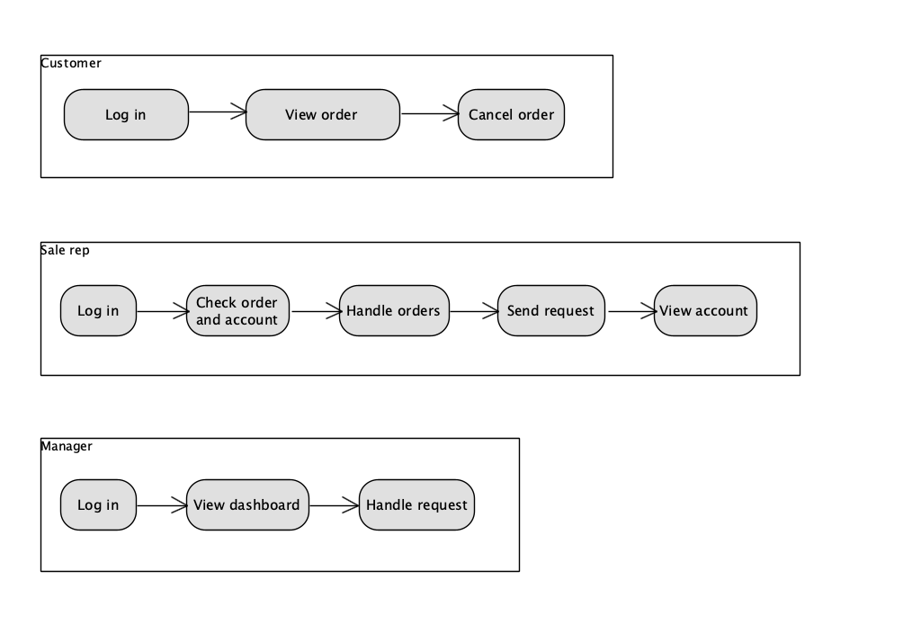

Customer

1. Log in

After executing the sql script. Now open the browser to access web page for customer. This time, please log in with account given below:

|  |  |
| --- | --- |
| Username | Password |
| Sherry | password |



After logging in, you will see the **welcome message with ‘Sherry’ username.** You will act as Sherry now.

1. View order

Now, go into the orders section and you will be able to view the 3 orders having been initialized for you in scrollable list. All orders right now are in **processing** because, recall that, the sale rep’s **initial quota is 1000**, which is enough to handle the orders.

1. Cancel order

Now try to delete any one of them, you will be **alerted and refused** because customers cannot cancel any orders made after 24h.

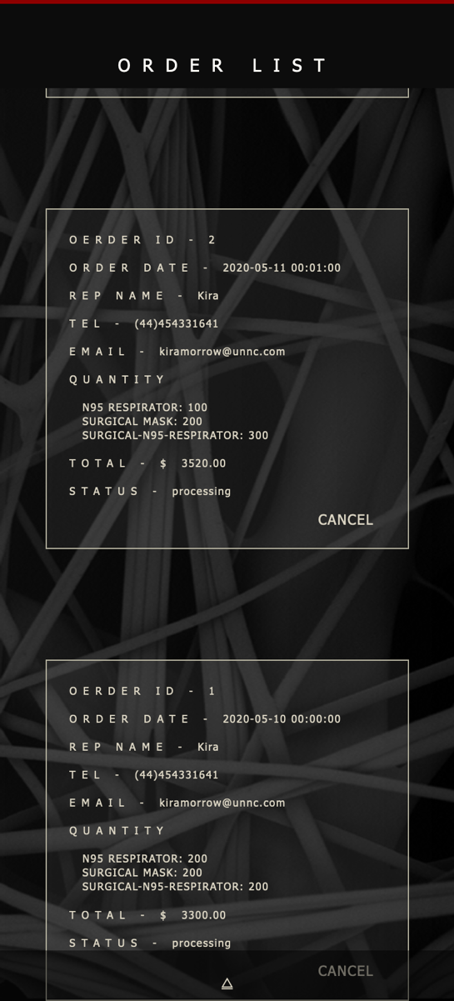 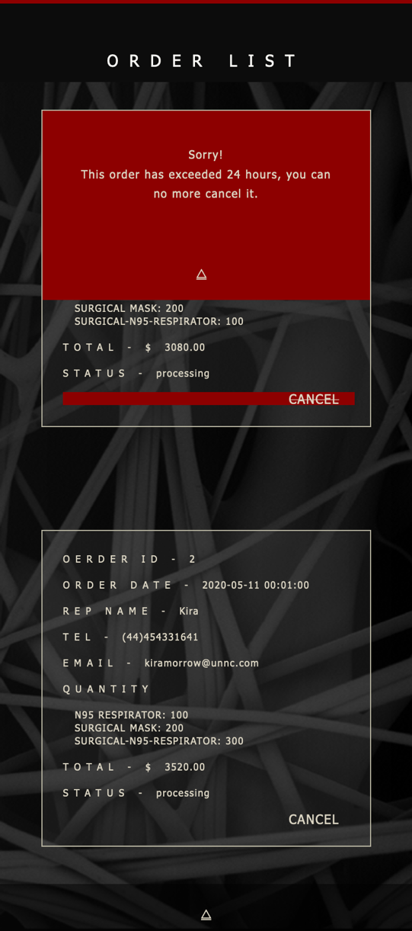

Now we have done customers’ view, please access web page to log in as staff.

Sale Rep

1. Log in

Please log in with account given below:

|  |  |
| --- | --- |
| Username | Password |
| Kira | password |

1. Check order and account

After logging in successfully, please click both **orders** and **account** buttons to view your orders.

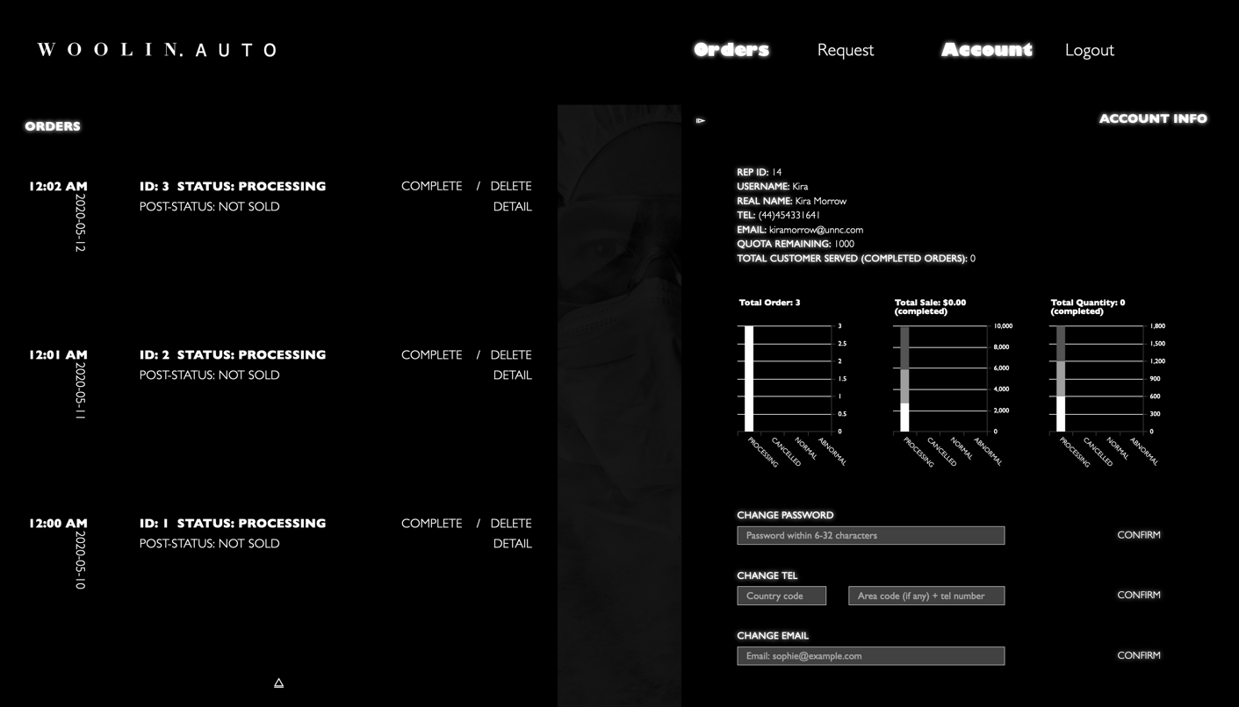

You will see that, all your orders are in processing, and your current quota remaining is 1000.

1. Handle orders

Now, close the account section, and then try to complete order with ID 3 by clicking **complete** button. You will success because your quota is enough to handle this order with 600 quantities. A confirmation message will slide down.

Now, you **click again the request button** to refresh this section, you will see that except the order you just completed, all other two orders are now having **status ‘completed’ and post status ‘abnormal to be reviewed’.**

Because after completing order ID 3, your quota remaining became to 400, which is not enough for handle any of other 2 orders exceeding 24h. The updating mechanism will automatically complete these 2 orders for you but mark as **abnormal to be reviewed, which will be noticed by manager once he/she logs in.**

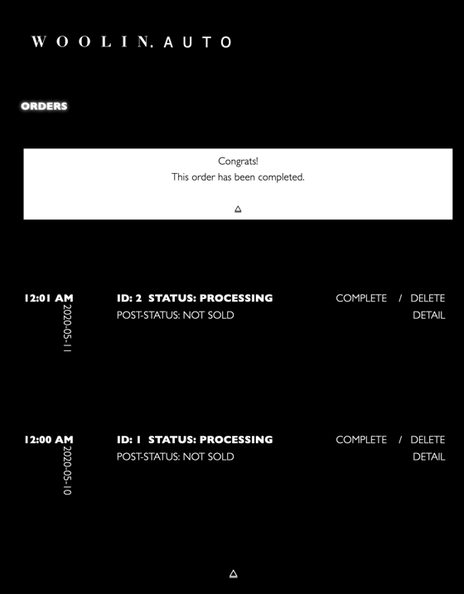 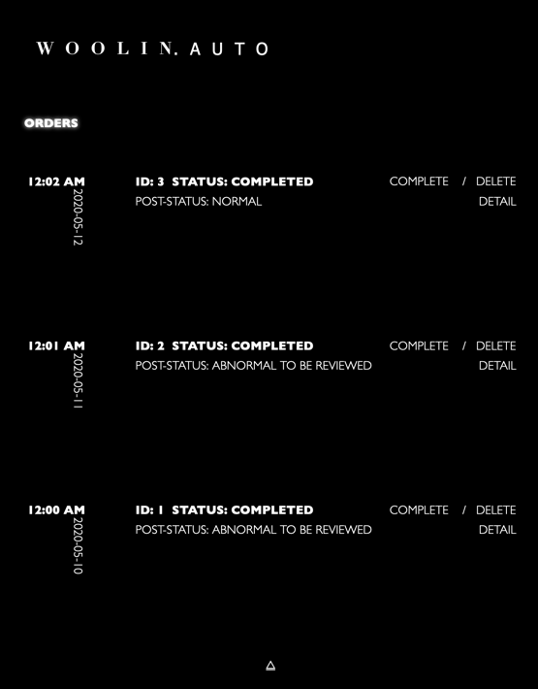

1. Send request

Once be aware that your quota is not enough, you better send a request for updating your quota by clicking **request** button.

Notice that, when checking your quota in request section, the message will switch to ‘**quota exceed’ and ‘REGRANT’ from ‘quota remaining’ and ‘UPDATE’ as mentioned in scenario 1**. Because even your 2 orders are abnormal, they are still completed automatically by the system, your quota will be subtracted accordingly anyway.

*(Therefore, it is really sale reps’ job to be active all the time to check his quota remaining and participate all cases to prepare asking more quota. Manager can use this mechanism to monitor the activeness of each sale rep)*

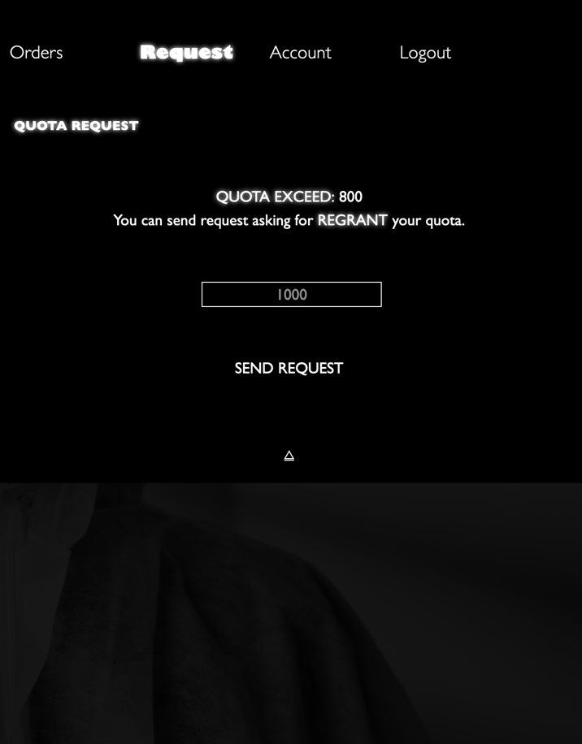

Now, you can ask for a quota request with quantity 2000 because 1000 is way not enough when you have a negative quota 800.

1. View account

After sending request successfully, check your account by clicking account button, your statistics graphs will have 2 more abnormal orders.

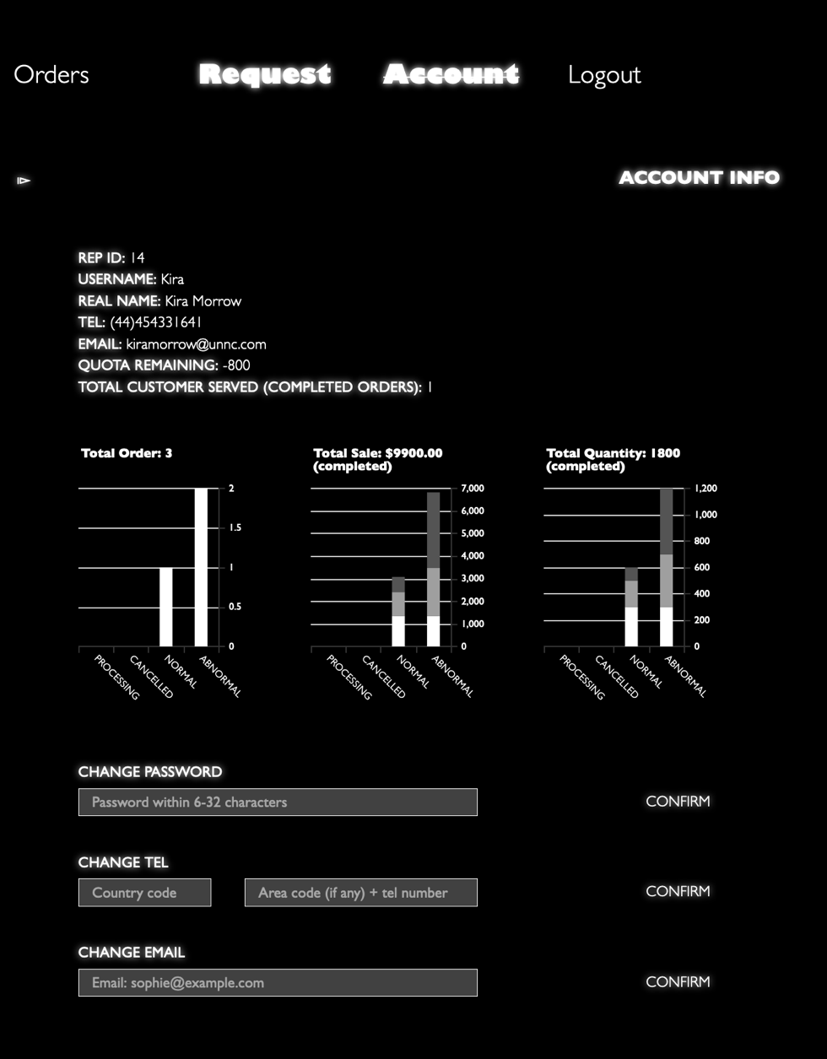

Now, you have done acting this unenterprising sale rep. Please open a new web page to access manage page as the same operation in scenario 1.

Manager

1. Log in

Recall that your username is ‘manager’ and password is ‘password’

1. View dashboard

After logging in, you will directly be aware by **the red color** in **Abnormal Order List panel, which means that new abnormal orders has been done without your checking.**

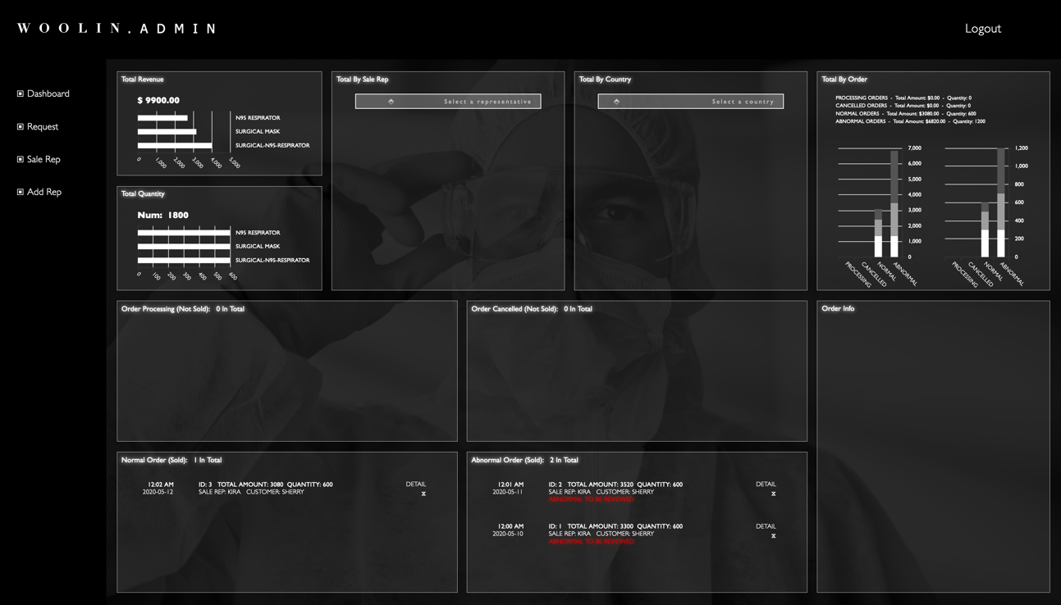

Please also check the total data in total revenue, total quantity and total by order panels (recall that abnormal orders are consider complete and sold).

You must be unhappy with the new anomaly, **click detail button** of order ID 2 right now to check its detail.

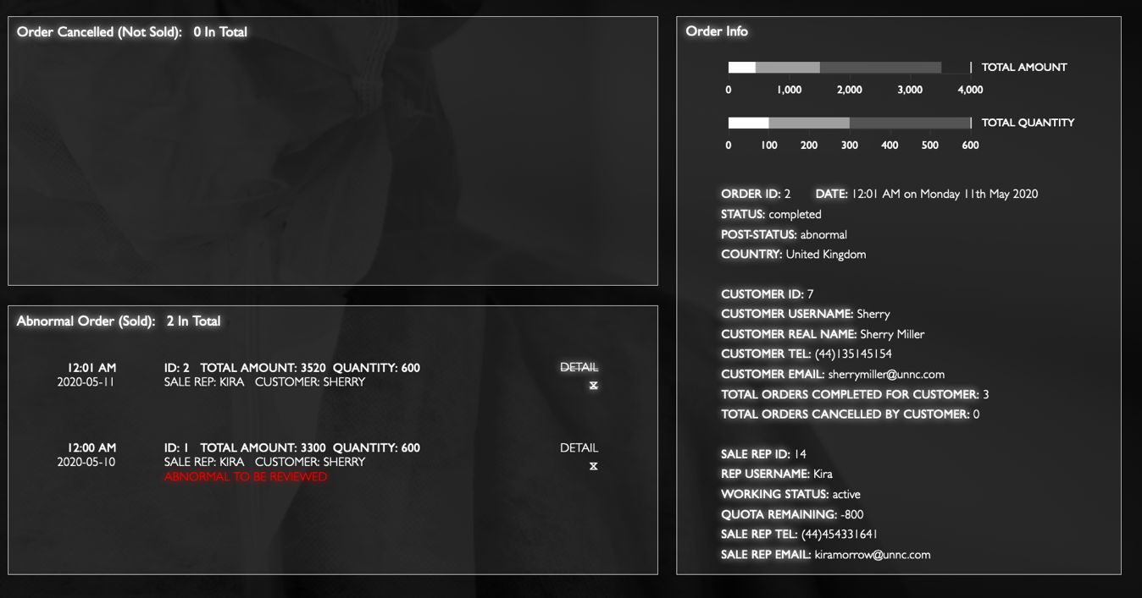

You will notice that, once the information fades in from the **Order info panel,** the red line of specific order selected in the abnormal order list disappears and the status becomes to **simply ‘abnormal’ from ‘abnormal to be reviewed’, this means you have already checked this orders.**

After check all details of these 2 abnormal order, try with other panels and see statistics.

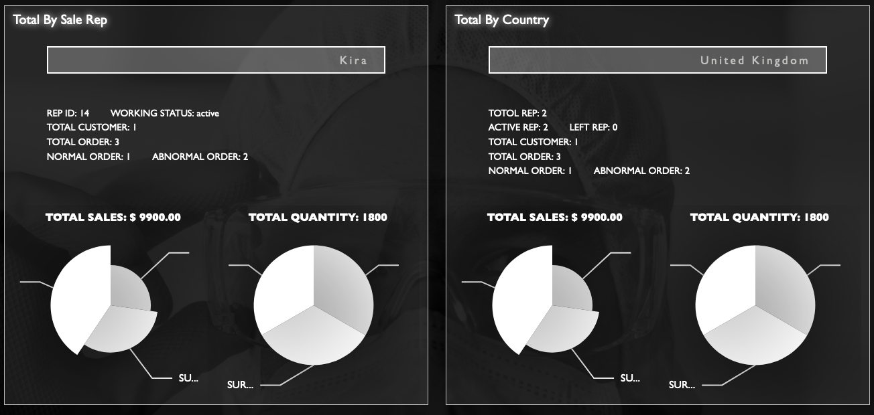

1. Handle request

Knowing that sale rep Kira’s quota is insufficient, you can move to check if she has sent any request to you.

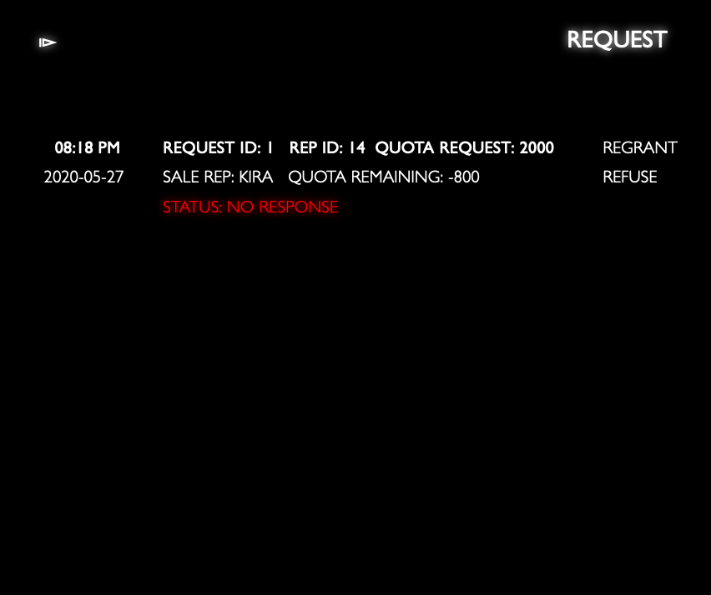

Seems like Kira is not that lazy at all, at least, she has sent a request to ask more quota. You can now **regrant** the quota for her.

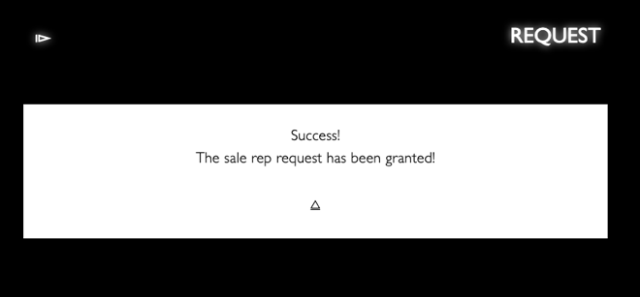 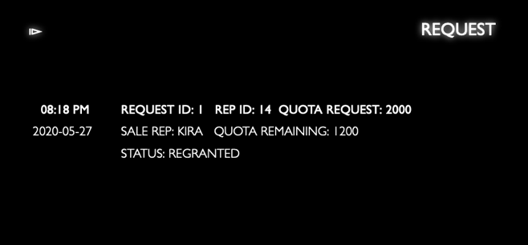

Congrats! You have done with all scenarios given. Hopefully, you have already familiar with this web system. Now you can feel free to manipulate and play with all accounts given to test more about this web!

# RULE, FUNCTIONALITY & FEATURE IMPLEMENTATION

*Note: This section discusses lists of rules and functionalities of different roles of users and how they are implemented by web technique, please cross-reference with introduction in TEST & INSTRUCTION section.*

Customer

1. Log in & Register

After accessing into the web page, what presented to customers is a login/register section. The first black panel is for customer to log in, with optionally a button to switch to register section implemented by **jQuery event and animate functions**. Complementarily, in the register panel, a log in button is attached for customer to switch between.

In log in panel, the customer will be asked to input his/her username and password, after clicking login button below input box, a **server-side validation** implemented by **Ajax request and PHP connecting to database** will be triggered. (1) On fail, a prompt div will slide down to alert user the mistake; (2) On success, the customer will be directed to home page automatically implemented by **jQuery trigger function.** Subsequently, a **24h-life-span cookie** called ‘username’ containing customer’s unique username (check username in DATABASE DETAIL section) is set by **jQuery cookie function**.

In register panel, the customer will be asked to input all information required. Every time an input box is blurred, a **client-side validation implemented by javascript** will be executed. On fail, the corresponding message of that input will pop out. The customer will be prompted and refused to register if some invalid inputs exist. Once there is no invalid input, clicking register button will trigger **server-side validation** implemented by **Ajax request and PHP connecting to database** to check if the **username or passport ID** has already been registered (The web checks uniqueness of passport ID to prevent malicious users from creating multiple accounts). On fail, the corresponding message will pop out. On success, the welcome message will pop out and redirect customer to log in panel automatically. The customer can then log in.

1. Switch to home page

After accessing the web page, what presented to customers is a login/register section. However, in order to let user check basic commodity information easily, customer can move to home page by click the home page button at left-right corner with/without logging in.

Then, there will be a login button at the right corner in navigation bar of home page, a welcome message in the left will contain “please log in!”. If the customer has already logged in, the login button will switch to logout. And the welcome message will contain customer’s username.

Once starting purchasing (see purchase cart section) or checking orders (see order section), the web will check if the customer has logged in by a **24h-life-span cookie** containing customer’s unique username (set in login section). (1) If cookie is null, the customer will be prompted and redirected to login section automatically; (2) If logged in, all further operations of customer will depend on this cookie.

1. View commodity info

At the bottom of home page, there is scrolling box containing information of 3 types of masks: N95 Respirator, Surgical Mask and Surgical-N95 Respirator, which is implemented by ‘**setInterval’ function in javascript.**

In the sub-navigation bar, customers can **hover** specific type of commodity to stop animation of the scrolling box if they want to check it for more time.

1. Purchase cart

When starting purchasing, customer can click the purchase cart button at the right-bottom corner to invoke the purchase cart section implemented by **jQuery event and animate functions**.

The commodity names and their corresponding unit price will show up in cart. All unit prices will be acquired from **Mask table** (see DATABASE DETAIL section) **in database** every time purchase cart is invoked, because the unit price may be changed by time.

The customer can select quantity of each type of commodity by item selectors in the right hand side by either clicking + / - button or input quantity number directly (if invalid quantity is input, the customer will be alerted and quantity will be set to 0). There is additionally a total calculator at the left-bottom of cart section to inform customer’s current total amount **implemented by javascript.**

1. Appointment

Once the customer decides to place the order by clicking pay button in purchase cart (total amount as 0 will be prompted and refused to make order), the appointment section will be invoked with a statement of why customers need to appoint sale reps for orders.

After reading the statement, the sale rep selection panel will show up containing all active (**see working_****status attribute of Rep in DATABASE DETAIL SECTION**) sale rep from the same region (treated as country in this web) as customer’s. Basic information of selected sale rep will slide in by **Ajax request and PHP connecting to database**. The customer will have knowledge of the rep’s remaining quota to choose freely according to his/her order quantity but be still able to choose one with insufficient quota. Not choosing any sale rep will be prompted and refused to confirm the order request by **client-****side validation checking if the selection bar has any sale rep name.**

*Note: 1. We assume the sale reps and customers will contact by telephone or email provided in order information. 2. If there is no sale rep currently active in customers’ country, they cannot make any order, unfortunately.*

By selecting sale rep successfully, a confirmation message will slide down with a detailed order information following aside.

1. Order check

There is a scrollable order list section for customers to check all orders they have made with all current status (processing, completed and cancelled see **status attribute of Orders in DATABASE DETAIL SECTION**) by clicking the orders button in the navigation bar.

Customer can view and cancel specific orders with some restrictions: (1) The customer can only cancel orders that are currently in processing and within 24h (2) If the customer intend to cancel orders exceeding 24 hours, orders have been completed or orders have been cancelled (either by customer or sale rep with insufficient quota), prompt message will slide down accordingly. All order information and **server-side validation are** **implemented by Ajax request with PHP connecting to database**. Once the cancel successes, the order list will be refresh automatically by **jQuery trigger function.**

Sale Rep

1. View customer home page

As mentioned in USER & INTERFACE section (treat both customers and sale reps as users), in order makes sale rep acquainted with customers’ operation for better service, sale rep can view information home page or even create their own account.

1. Log in

There is a special staff entry button for sale reps to log in their staff account at the log in section in ‘home.html’. Once clicking, the web will jump to a new staff page ‘staff.html’ with sale rep log in section. Similar with customer log in section, according prompt message will slide to prevent reps logging in if **server-side validation** fails. On success, the rep will be directed to staff home page, and a **24h-life-span cookie** containing rep’s unique username is set. All operations further in staff page will depend on this cookie.

*Note: There is no register section in staff page because we consider this task as manager (admin)’s job (see functionality & feature implementation in manager section)*

1. Order check

Once logging in, sale rep can check all orders appointed to him/her with all current status (processing, completed and cancelled, see **status attribute of Orders in DATABASE DETAIL SECTION**) in a scrollable order list section by clicking orders button in navigation bar.

(All section buttons currently selected in navigation bar will be bold and in white glow, and clickable buttons in each section will be in glow as well when hovered implemented by **jQuery event and animate function**.)

All basic information will be presented in order list section containing order ID, status and post status (not sold, normal, abnormal and abnormal to be reviewed, see **post_status attribute of Orders in DATABASE DETAIL SECTION**). If the rep intends to check details of specific order, the detail button can be click.

Subsequently, an additional order detail section will be invoked containing all order and customer’s information enough for rep to contact customer and then handle the order. All information acquired is **implemented by Ajax request with PHP connecting to database based on cookie** (containing rep username) **and selected order ID**.

1. Order operation

Each order in order list can be handle by complete or delete button under various restrictions:

On complete:

(1) The rep with sufficient quota can directly complete orders that are currently in processing status;

(2) The rep trying to complete orders with status as already completed, cancelled (both by user and rep) will be prompted with corresponding message and refused;

(3) The rep with insufficient quota trying to complete orders in processing will be prompted with corresponding message and refused;

On delete:

1. The rep with insufficient quota can directly delete(cancel) orders within 24h;
2. The orders of rep with insufficient quota exceeding 24h will be automatically updated as completed (status) and abnormal to be reviewed (post status), if manager has done checking the new abnormal order, the post status will be set as abnormal (see functionality of manager section). The automatically updating is implemented by an **Ajax request every time there is a web page loaded.**
3. The rep trying to delete orders that has been cancelled or completed will be prompted with corresponding message and refused;

All information modification is **implemented by Ajax request with PHP connecting to database** and all operation restriction check is implemented **by client-side validation based on html content in order info.** After every information updating, the order list content will be modified automatically without refreshing the web **implemented by javascript html function.**

1. Send quota request

The rep can check his/her quota remaining/exceeding in both request section and account section (see account section below). Once the rep intends to (1) ask for **updating** quota (when quota remaining > 0); (2) ask for re-granting the quota (when quota exceeds, namely quota remaining <= 0), the request button can be clicked in navigation bar.

The default quota quantity request is 1000, and can be changed freely by reps. If invalid input, the rep will be alerted and the quantity will be reset to 1000 **implemented by client-side validation.**

By clicking send request button, a **server-side validation** checking if the rep has already a request without response (updated/regranted/refused **see request status attribute in DATABASE DETAIL section**). If no, then a new request will be created with no response status to be handled by manager. If yes, then the rep will be prompted accordingly and refused.

1. Account check

The rep can check his/her own information and working statistics by clicking account button in navigation bar.

The account section contains rep’s basic information **implemented by Ajax request,** statistics of his/her sale performance **in bar diagram implemented by echart** and additionally a modification section (see account modification section below).

The detail data of statistic diagrams can be viewed by **cursor hovering.**

1. Account modification

The rep can modify part of his/her own account information once created by manager (see functionality of manager section): password (once changed, the manager will have no knowledge of the account’s password), telephone and email (in case that the manager reassign the rep to another country, these modification is necessary).

The **bilateral-side validation** is similar with that in register section.

Manager

1. Log in

As mentioned in USER & INTERFACE section, we assume that there is only one manager with administrator role. Therefore, the information of manager is considered not necessary in this project, and no data for him/her will be stored in database. The username and password are embedded in web source code directly. **For testing purpose, the username for manager is simply “manager” and password is “password”.**

After logging in, the admin home page will show up, and a **24h-life-span cookie** called ‘manager_login’ with boolean value true will be set. In this period, the log in section will be no more appeared. If logged in failed by **client-side validation**, manager will be prompted and refused like that in customer and sale rep.

1. View all statistics data

After logging in, the very first panel shown is a dashboard section, which contains various small panels describing all statistical data implemented **by Ajax request with PHP connecting to database and Echart** (The detail data of statistic diagrams can be viewed by **cursor hovering**)**:**

1. Total revenue

Data describe the total amount sold by all sale reps including both normal orders and abnormal orders (excluding order in processing and order cancelled)

1. Total quantity

Data describe the total quantity of 3 types of masks sold by all sale reps including both normal orders and abnormal orders (excluding order in processing and order cancelled)

1. Total by sale rep

Data describe the basic sale performance, total amount and quantity of 3 types of masks sold by specific sale rep including both normal orders and abnormal orders (excluding order in processing and order cancelled)

1. Total by country

Data describe the basic sale performance, total amount and quantity of 3 types of masks sold by specific country (region) including both normal orders and abnormal orders (excluding order in processing and order cancelled)

1. Total by order

Data describe the total amount and quantity of 3 types of masks sold or will be sold in orders under different situation (processing, cancelled, normal orders and abnormal orders)

1. Order processing list

Order list of all orders currently in processing (not sold)

1. Order cancelled list

Order list of all orders have been cancelled either by customers or by sale reps (not sold)

1. Normal order list

Order list of all normal orders have been sold (complete) by normal sale rep handling

1. Abnormal order list

Order list of all abnormal orders have been sold (complete) by unexpected sale rep handling (no response in 24h by sale rep with insufficient quota remaining to specific order)

Note: In abnormal order list panel, if there is any abnormal order has not been checked in detail by manager, the status of the specific order will be presented in **red line** with ‘abnormal to be reviewed’ text, manager will be notified and check it for detail (see Order info panel below). Once the detail info firstly presented in order info panel, the red line will be transform to normal **white** with ‘abnormal’ text and automatically synchronized to database by **jQuery event handling function and Ajax request.**

1. Order info panel

All detail information of specific order selected by manager will be shown in this panel by clicking detail button aside each order in order lists, with all statistical data of that order, sale rep and customer performance such as how many orders have been completed or cancelled by the customer, for **security and privacy issue**, the customer section is not design particularly in this web, manager is only able to view customer performance by checking specific order when needed. On the contrary, performance for sale reps will be presented in detail in sale rep section (see View sale rep info section below) from better monitoring.

1. Handle request

By clicking the request button in the left navigation bar, request handling section for all quota request sent to the manager will slide from right hand side. The options for each request will differ based on if the quota remaining for specific sale rep is positive value (1) If current quota remaining of sale rep > 0, two options will be update and refuse; (2) If current quota remaining of sale rep <= 0, two options will be regrant and refuse; (3) If the request has been refused, updated or regranted (**see request status attribute in DATABASE DETAIL section**), there will be no handling option.

By operating successfully, the prompt message will slide down and information for particular request will change accordingly and data will be synchronized automatically to database by **jQuery event handling function and Ajax request.**

Similar as in abnormal order list panel in dashboard section, request with no response status will be presented in red line for notify the manager, because sale reps can no more send other requests once they have already had request waiting for responding.

1. View sale rep info

As mentioned in Order info panel section, a separated section of sale rep performance is designed for better monitoring and regulating by clicking sale rep button in left navigation bar.

Similar as operation in total by rep panel in dashboard section, manager can select specific sale rep to check sale rep performance in detail.

Additionally, manage can assign sale reps to specific country and their working status (see working status attribute of Rep in DATABASE DETAIL section) in this section. After assigning successfully, prompt message will slide down and according information will be change and synchronized automatically to database by **jQuery event handling function and Ajax request.**

*Note: the country attribute can be null when creating rep account (see create new rep account section below) or assigned to be null for reason of interval, which is reasonable.*

1. Create new rep account

As the role of administrator, the task of creating accounts of sale reps is assigned to manager in add rep section, which can be invoked by clicking add rep button in left navigation bar. All operation is similar as what in customer register section, therefore no discussion in detail will be presented here. Once the account is created, its sale rep’s job to change his/her password or contact information when is needed.